**Starting with Deployment on AWS Spring Boot on AWS**

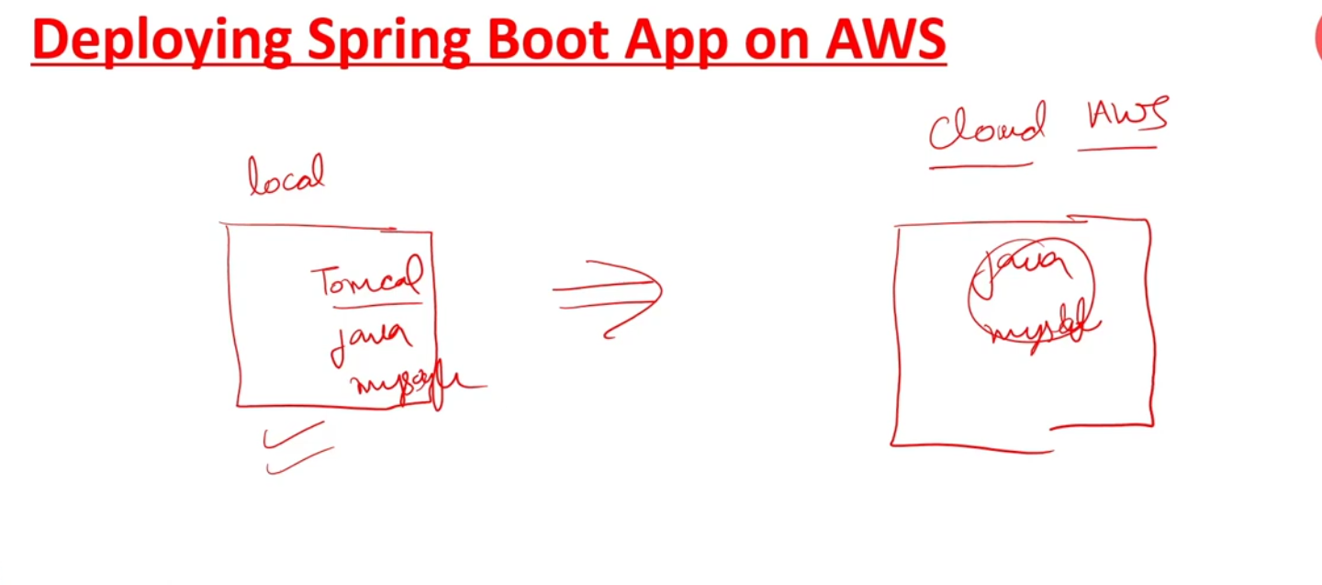

**Local service required**

**Java,mysql,**

**Cloud Aws service required**

**Java,mysql,**

**There are multiple services of AWS:**

1. **Amazon EC2 (**[**https://aws.amazon.com/ec2/**](https://aws.amazon.com/ec2/)**)**
2. **AWS Elastic Beanstalk (**[**https://aws.amazon.com/elasticbeanstalk/**](https://aws.amazon.com/elasticbeanstalk/)**)**
3. **Amazon RDS (**[**https://aws.amazon.com/rds/**](https://aws.amazon.com/rds/)**)**
4. **Amazon Route 53 (**[**https://aws.amazon.com/route53/**](https://aws.amazon.com/route53/)**)**
5. **Amazon S3 (**[**https://aws.amazon.com/s3/**](https://aws.amazon.com/s3/)**)**